**Meshack Nyagwencha Bosire**

**IVF370**

4.1

1. What is the total size of 1327 pieces of captured frames?
   1. 972kB
2. -What is the average bandwidth of the network traffic for 6 seconds?
   1. Bandwidth = size/time = 3816bytes/6 seconds = 3816*8/6 = 5088 bits/second
   2. 4507

C) How many frames were transferred through the NIC for 6 seconds?

29

D) What is the avarage frame size transferred for 6 seconds?

3816/29 = 132

115

Based on the Wireshark capture justify your answer to the following questions:

1. - What is the compression ratio in the case of pcap and txt file types?
   1. Size of pcap file = 501KB
   2. Size of txt file = 2.3MB
      1. Compression ratio = size of pcap file/ size of txt file = 501/2300 = 0.2178

What is the compression ratio in the case of pcap and pcapng file types?

size of pcap file = 501 KB

size of pcapng = 509 KB

Compression ratio = size of pcap file/ size of pcapng = 501/509 = 0.984

4.2

Time diagrams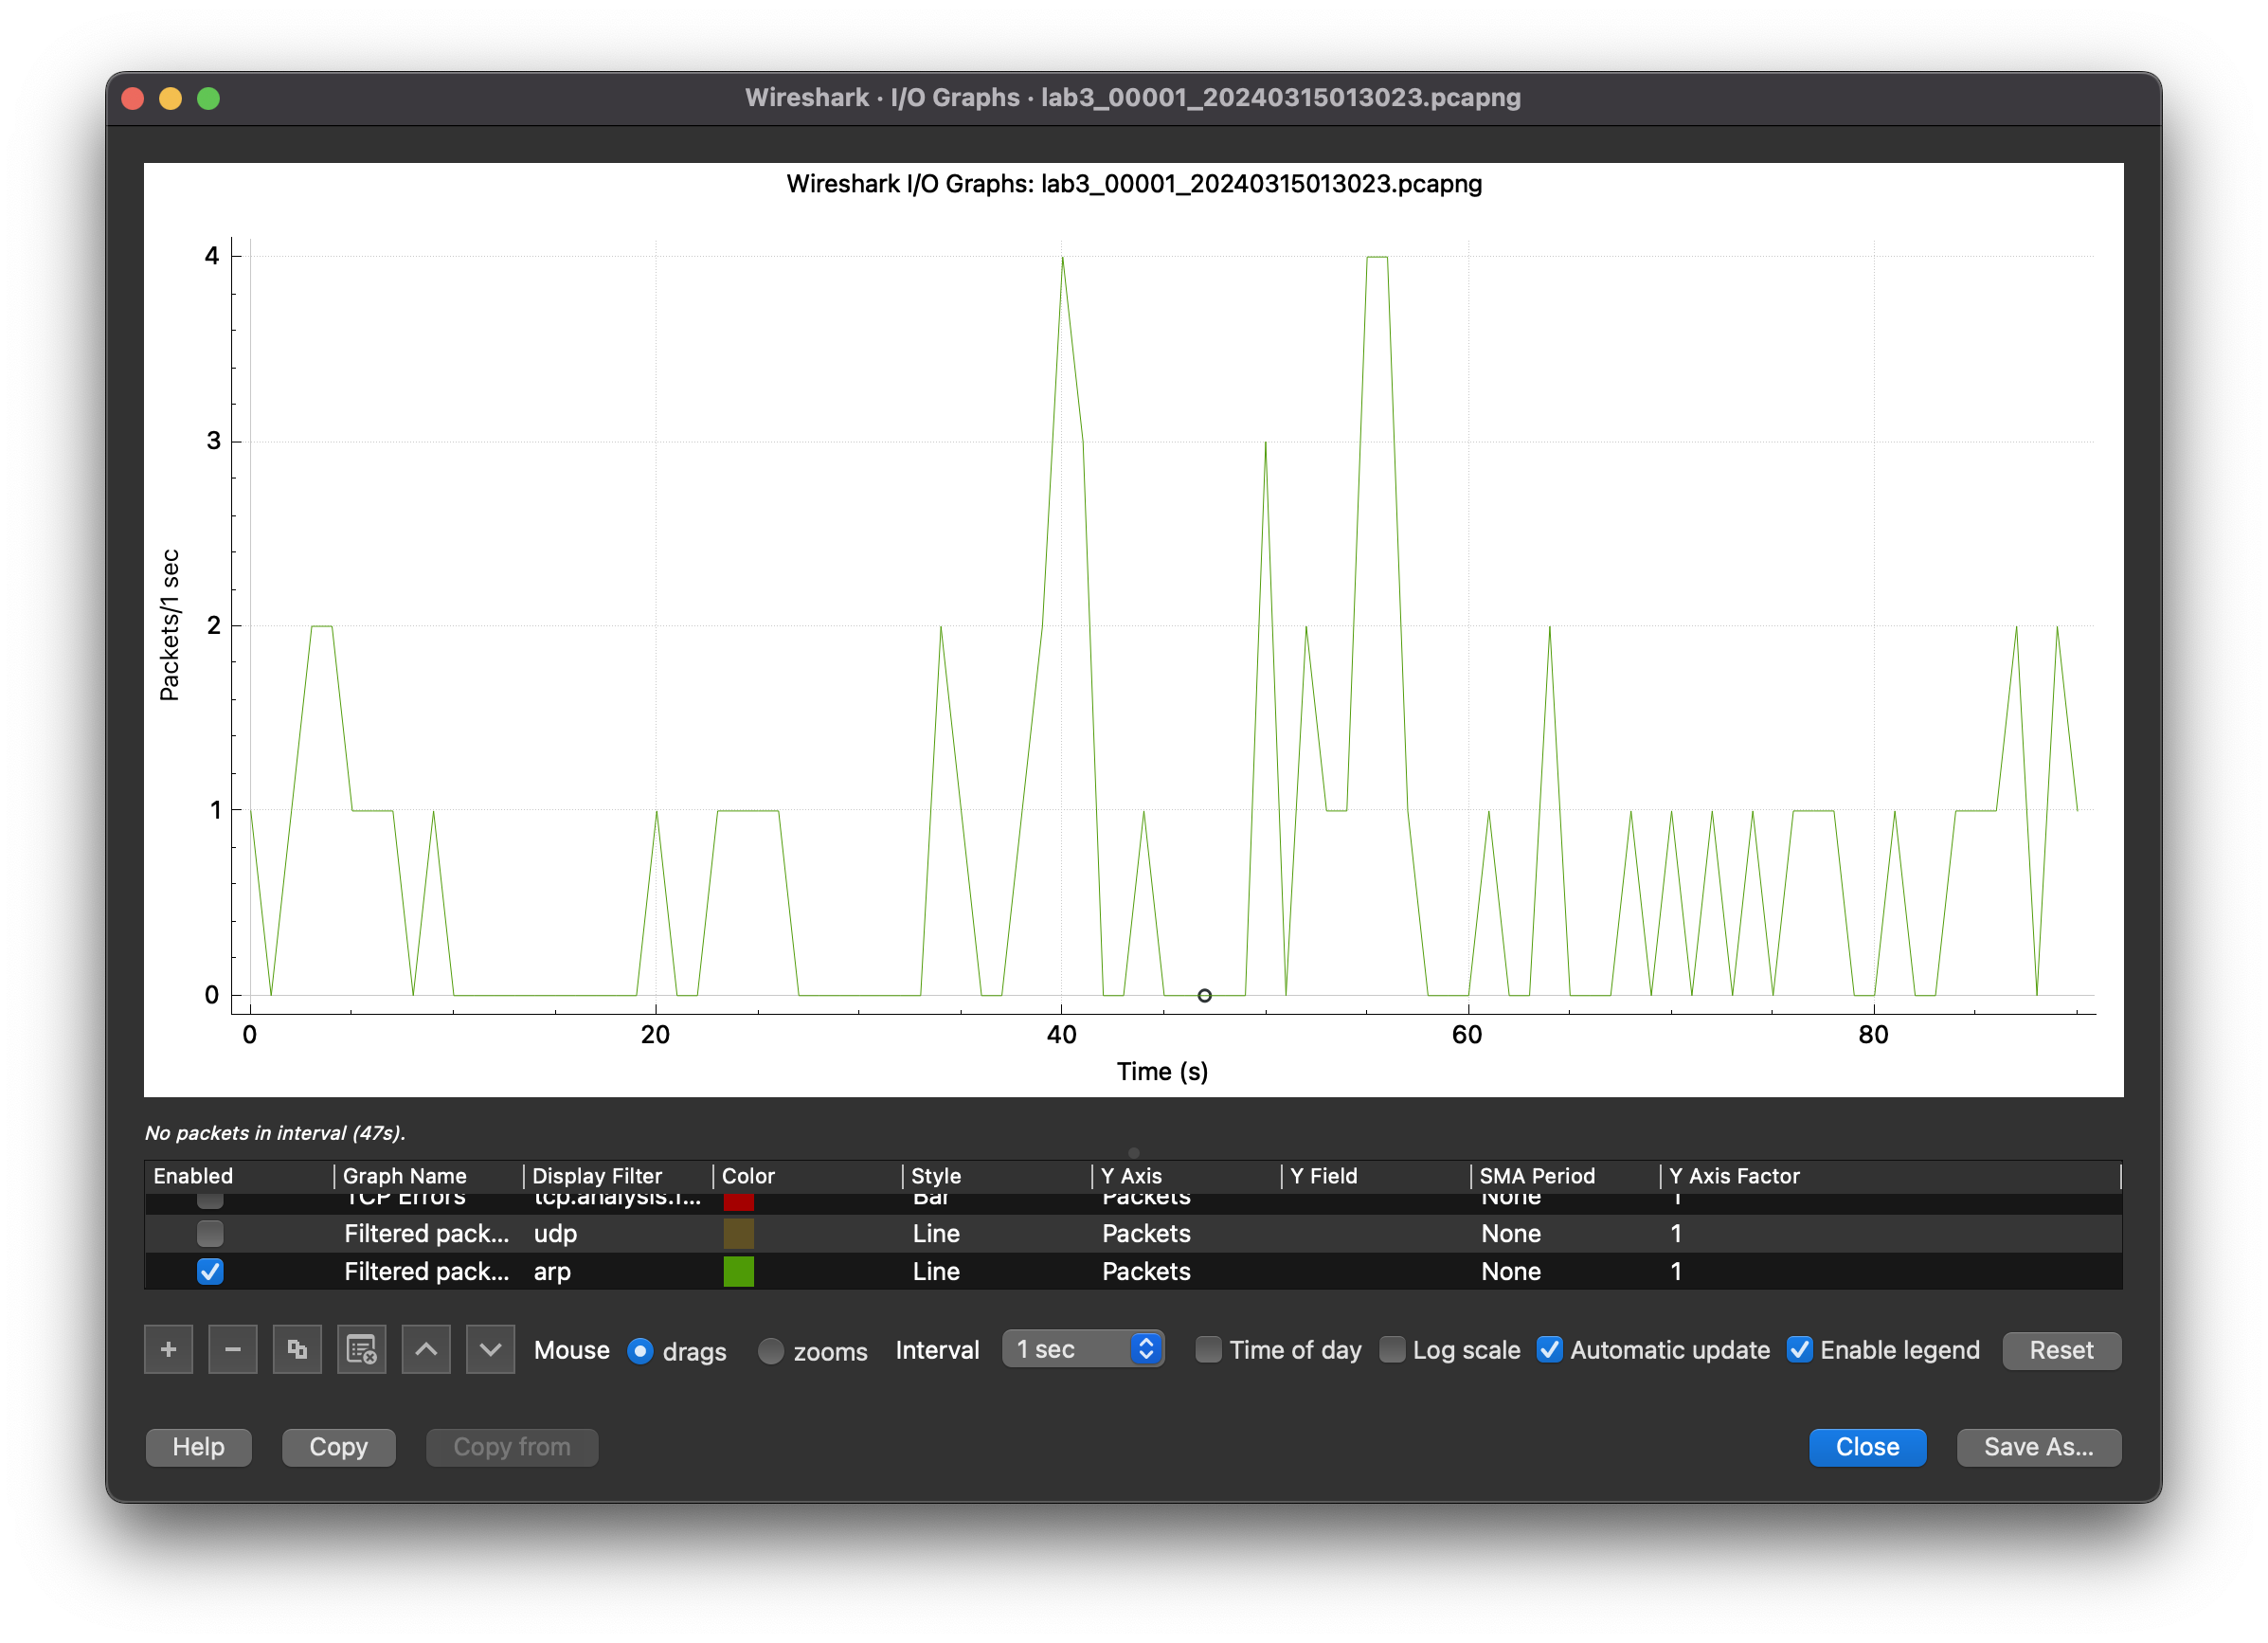

ARP/RARP

ICMP

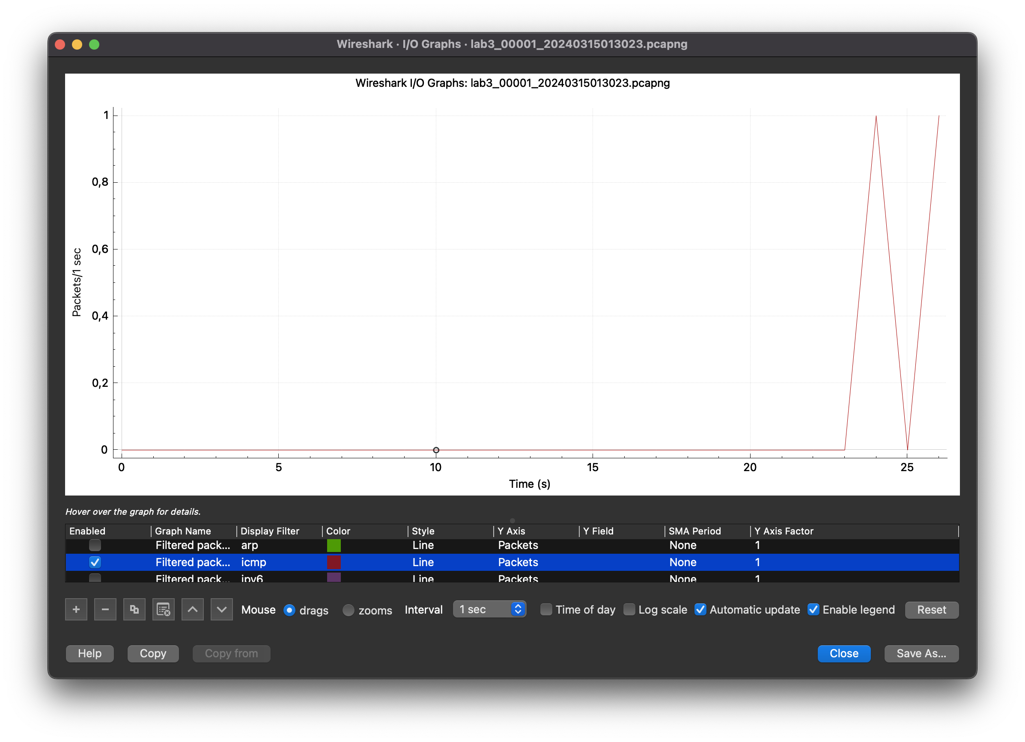

ICMPv6

IPv4

IPv6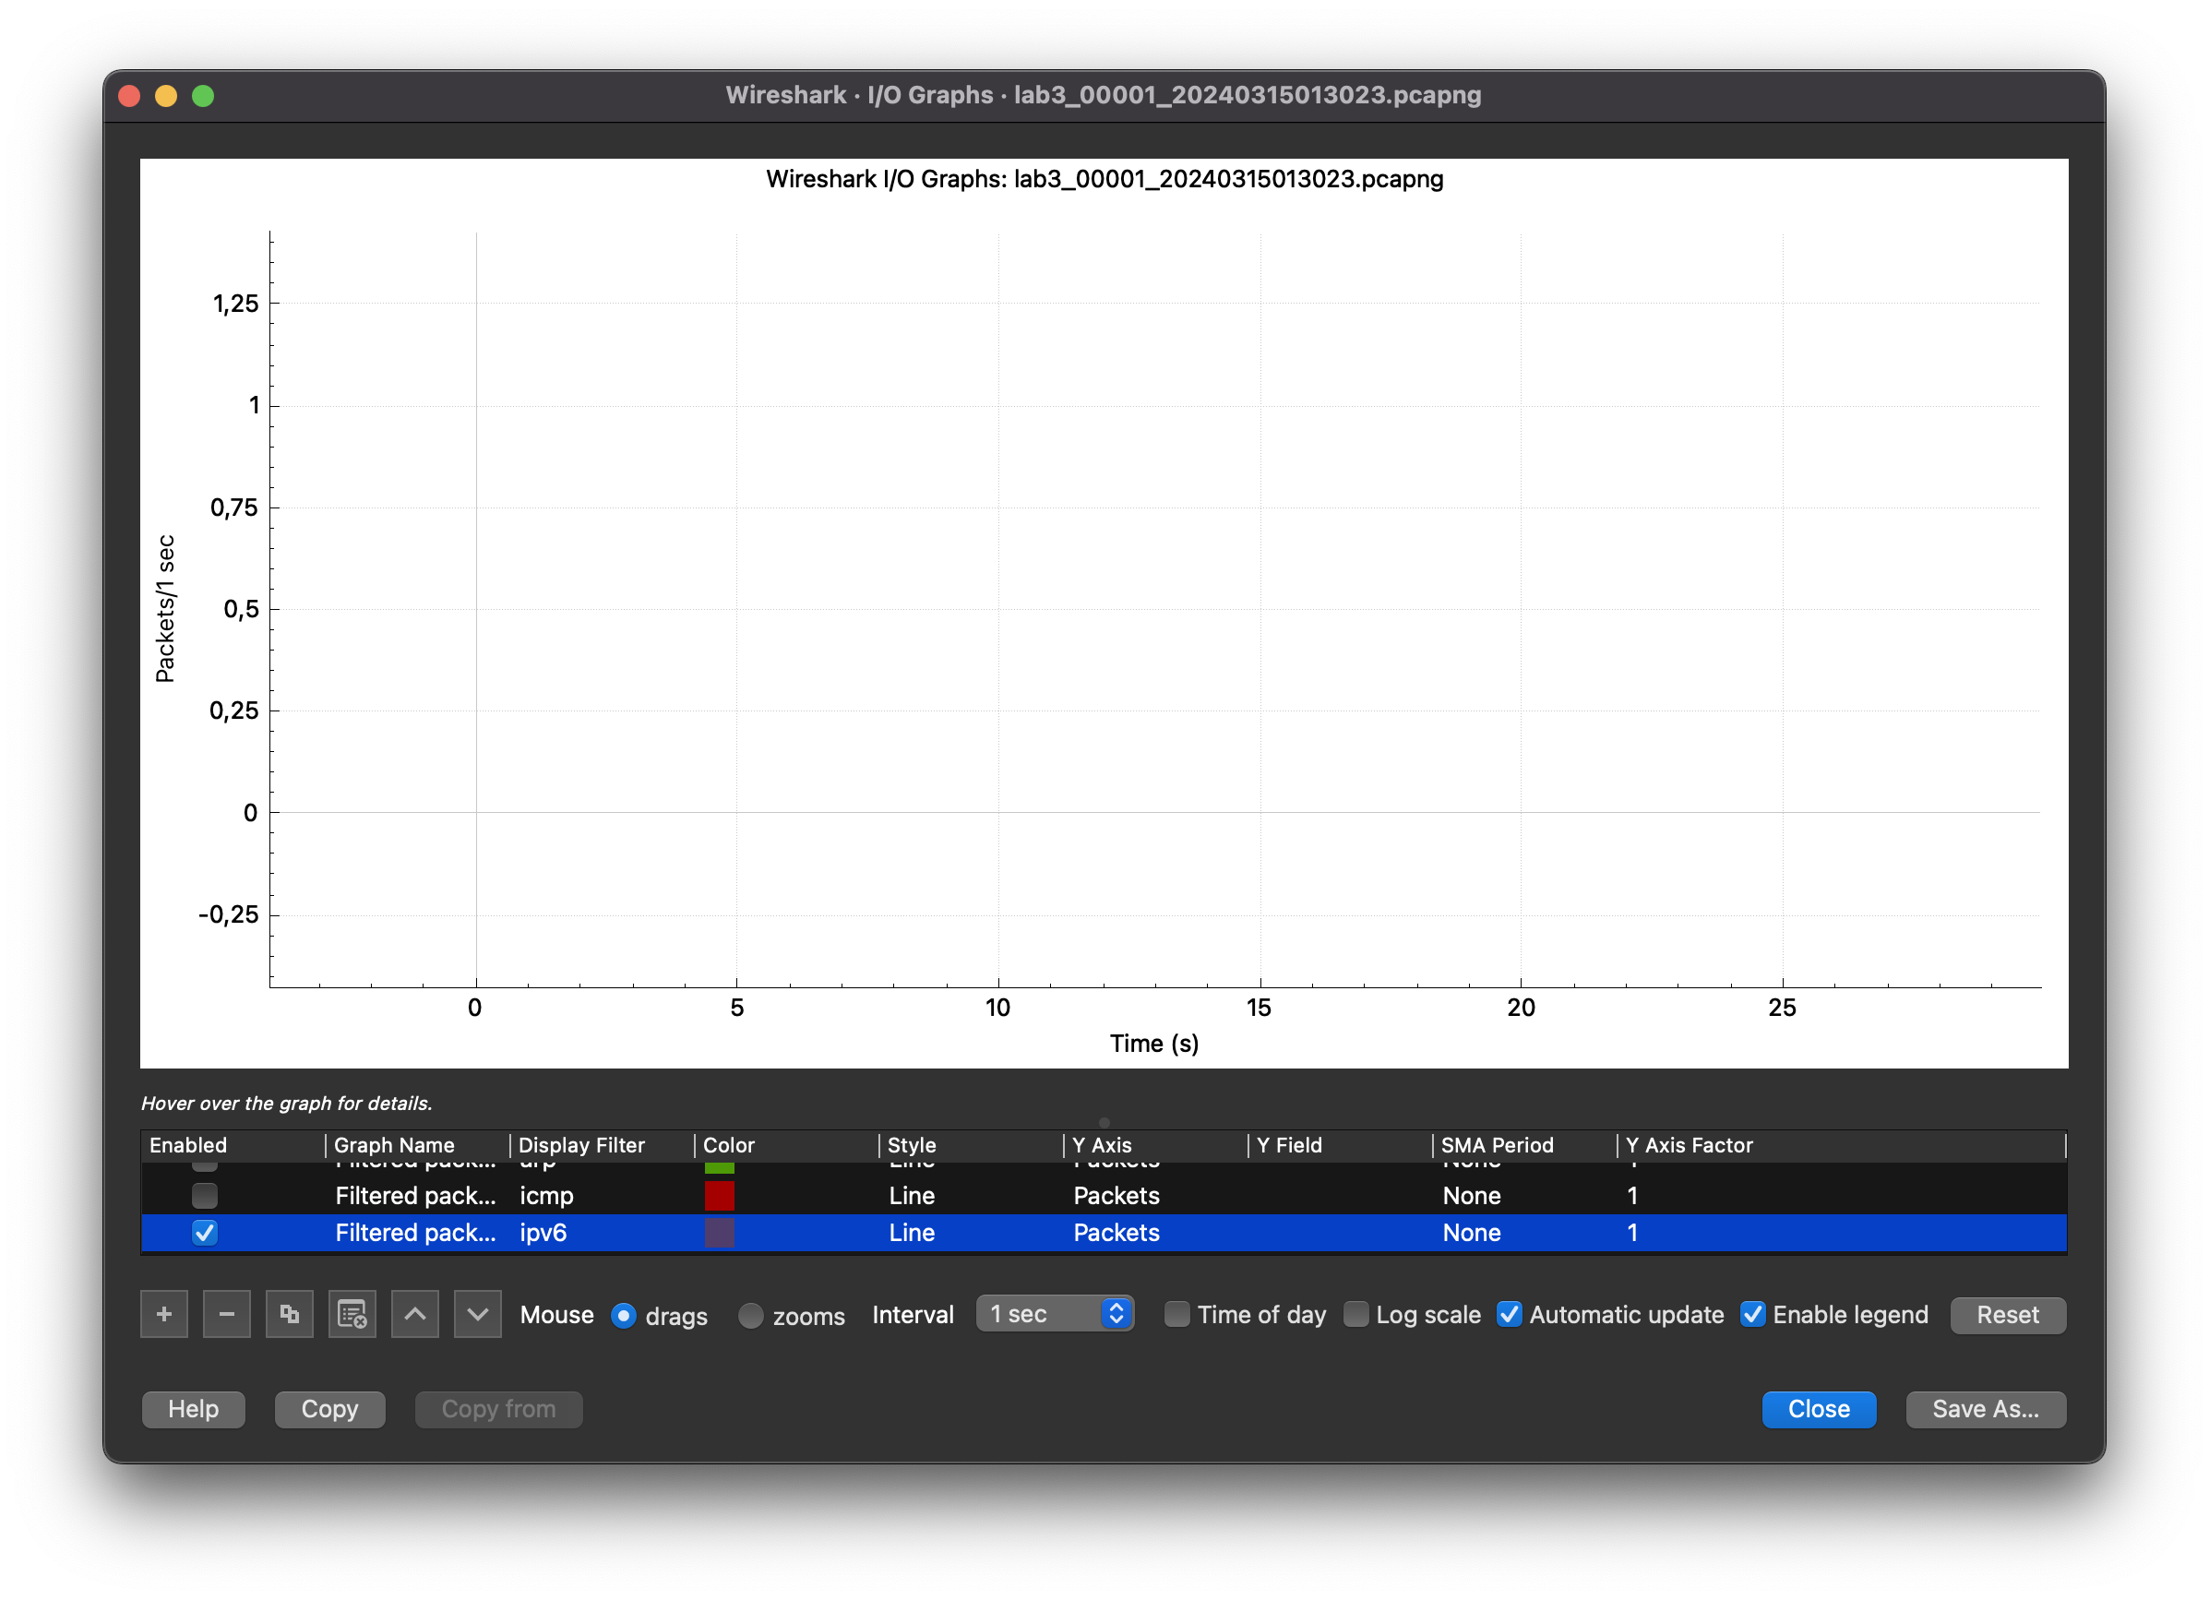

TCP

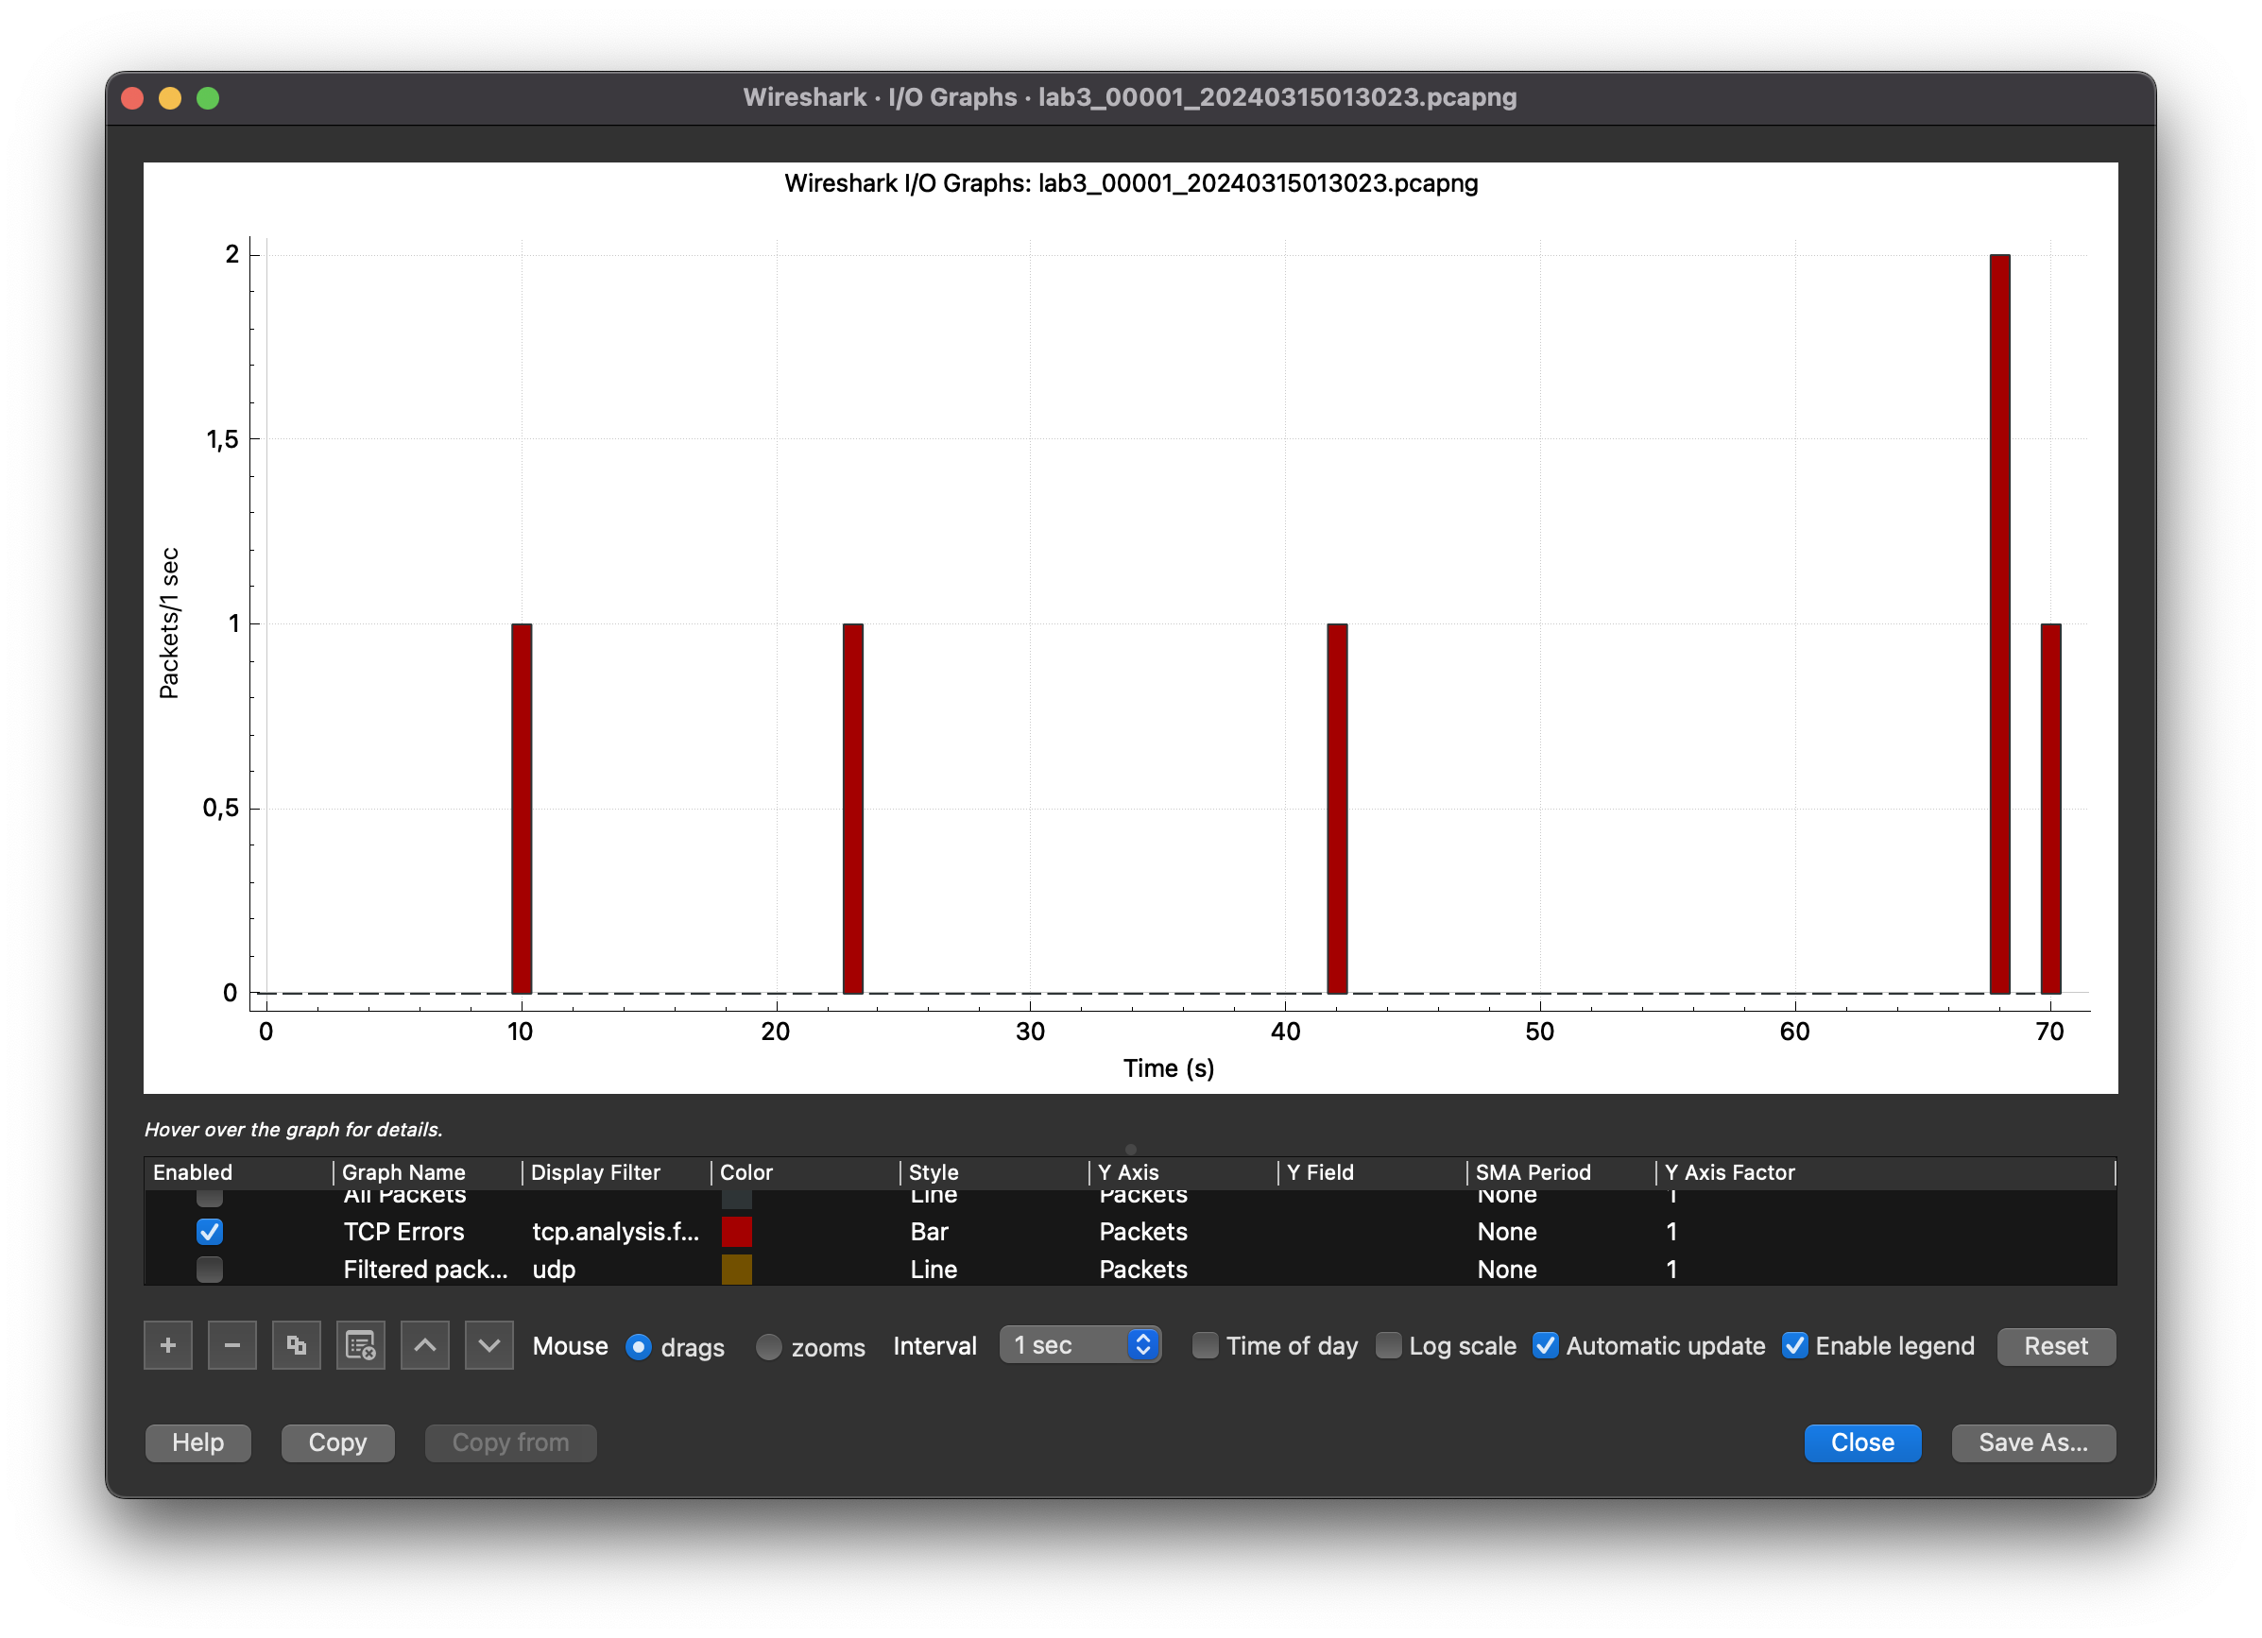

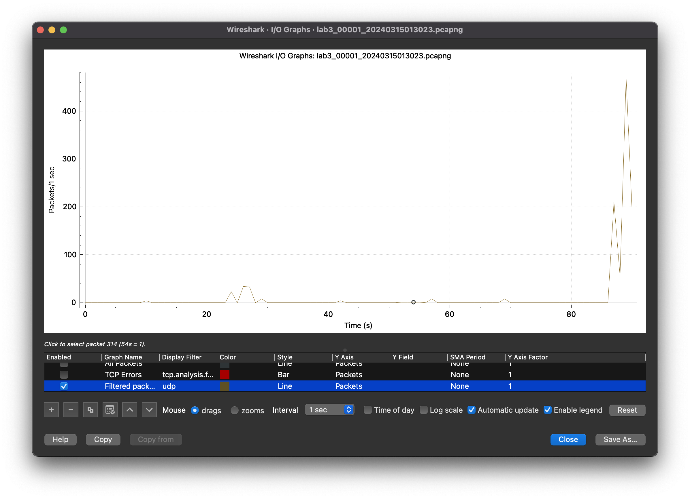

UDP

What is the OUI code of the Cisco company?

000142

What is the MAC address of the NIC module of your PC?

d0:88:0c:93:d3:1a

Where can you find the MAC OUI identifiers of NIC manufacturing companies on the Internet?

B) Identify the NIC MAC values according to the following questions:

Where can you find the MAC OUI identifiers of NIC manufacturing companies on the Internet?

1. IEEE Standards Association (IEEE-SA) Registration Authority
2. Wireshark OUI Lookup

* What are the MAC OUI codes of the following NIC manufacturing companies: Cisco, HP, Apple, Xiaomi, Huawei?
* Cisco - 00:00:0C Cisco Systems, Inc
* HP - 00:16:B9 ProCurve Networking by HP
* Apple - 00:03:93 Apple, Inc.
* Xiami - 00:9E:C8 Xiaomi Communications Co Ltd
* Huawei - 00:18:82 Huawei Technologies Co.,Ltd

4.3 A)

What is the capture rule which filters the network traffic of your own PC in the case of Wireshark?

Use the filter rule: host <your_PC_IP_address>

B) What is the capture rule which filters only those frames that are sent for the broadcast address in the case of Wireshark?

Use the following capture rule: dst host 255.255.255.255

4.4 A)What is the display rule which filters the network traffic of your own PC in the case of Wireshark?

Use the following display filter expressions: ip.src == <your_IP_address> or ip.dst == <your_IP_address>

B) What is the display rule which filters only those frames that are sent for the broadcast address in the case of Wireshark?

eth.dst == ff:ff:ff:ff:ff:ff

4.5) A) In the case of Wireshark where can we find the tail of the captured frame?

In Wireshark, we can find the tail of the captured frame in the "Frame" section of the packet details pane.

B) What do „.”characters indicate in the bottom field?

The "." characters indicate non-printable characters or bytes that cannot be represented as regular ASCII characters